Aim: To use an Amazon SageMaker Notebook to train a simple linear regression model on data stored in S3, then visualize the model's fit and evaluate its performance directly within the notebook.
Theory:
- Amazon SageMaker Notebook: A managed Jupyter notebook instance that provides a powerful, integrated environment for data exploration, analysis, and model training. It comes pre-packaged with common data science libraries and AWS SDKs.
- Amazon S3 (Simple Storage Service): A scalable object storage service used here to store the training dataset. SageMaker training jobs are optimized to read data efficiently from S3.
- Linear Regression: A statistical method for modeling the relationship between a dependent variable (target) and an independent variable (feature) by fitting a straight line to the data.
- Data Visualization: The process of creating graphical representations of data. In this lab, we will use a scatter plot for our data points and a line plot for our model's predictions to visually assess how well the model fits the data.
- Mean Squared Error (MSE): A common metric used to measure the performance of a regression model. It calculates the average of the squared differences between the actual and predicted values, providing a measure of the model's error. A lower MSE indicates a better fit.

Procedure:
Step 1: Launch a SageMaker Notebook and Initial Setup
First, we launch a new notebook inside SageMaker Studio and import the necessary libraries.

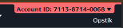
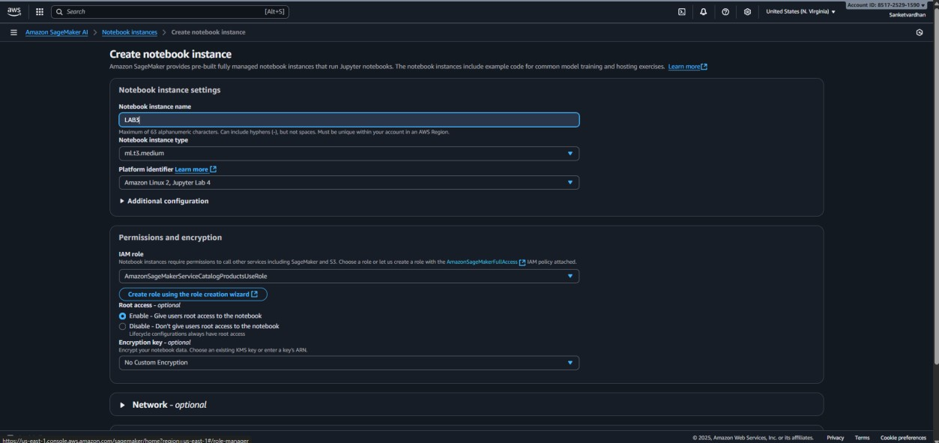
- From the SageMaker Studio Launcher, create a new notebook.

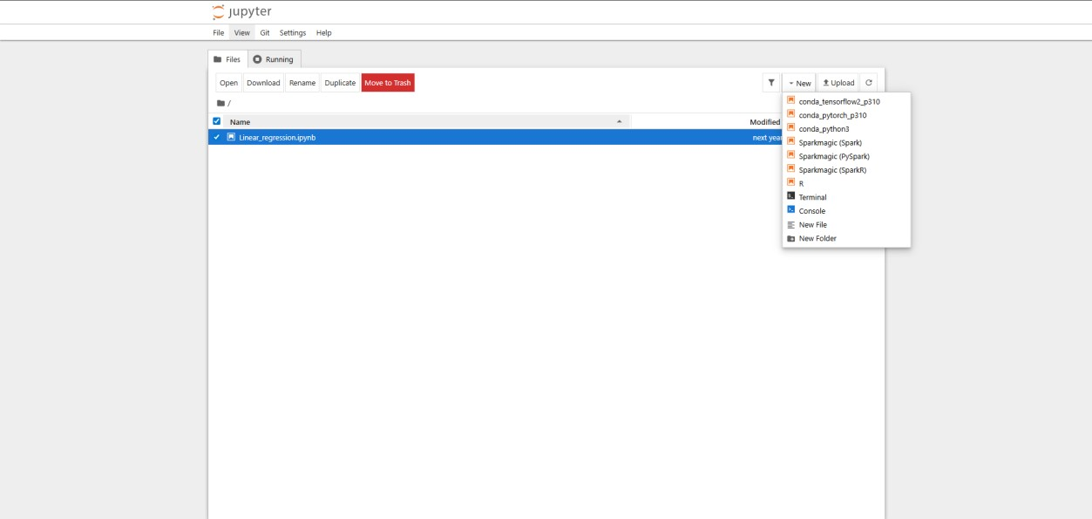
- Select the conda_python3 kernel.

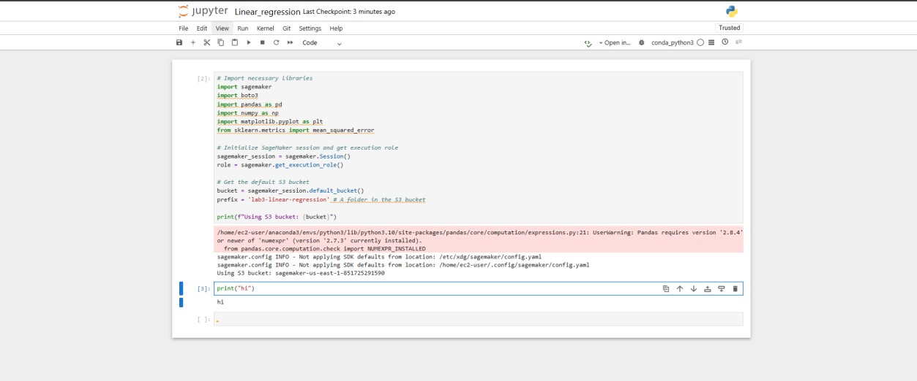
- In the first cell, run the following code to import libraries and set up the SageMaker session. This will also identify the default S3 bucket we will use.

Step 2: Generate and Prepare the Dataset
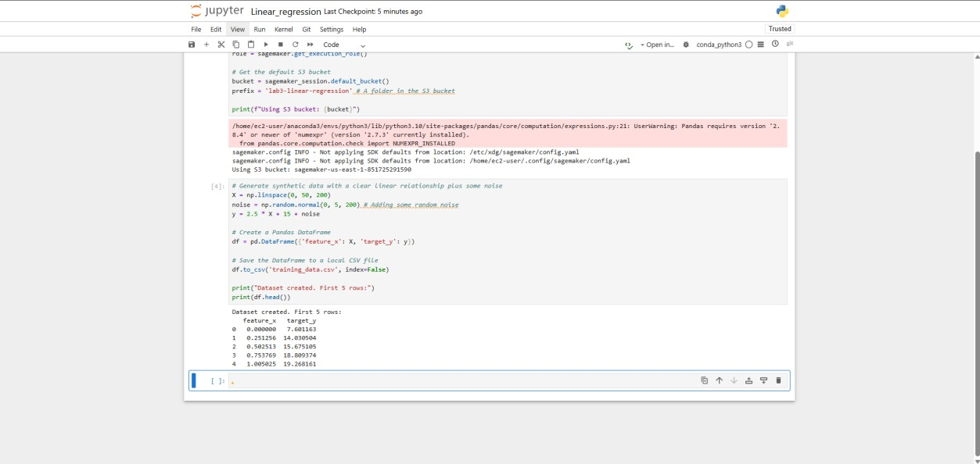
We will create a simple synthetic dataset that follows a linear pattern and save it locally. In a new cell, execute this code to generate data using NumPy.

Step 3: Upload Training Data to S3
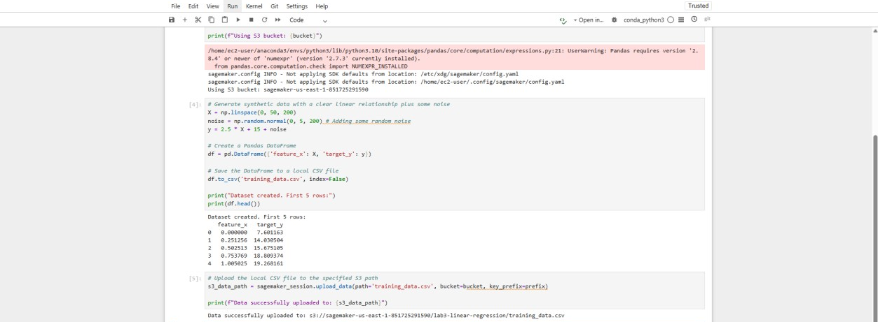
SageMaker training jobs work with data stored in S3. We'll upload our CSV file to the default bucket. Run the following cell to perform the upload.

Step 4: Train the Linear Regression Model with Scikit-learn
For simplicity and direct visualization, we can use the popular Scikit-learn library, which comes pre-installed in SageMaker notebooks, to train our model.
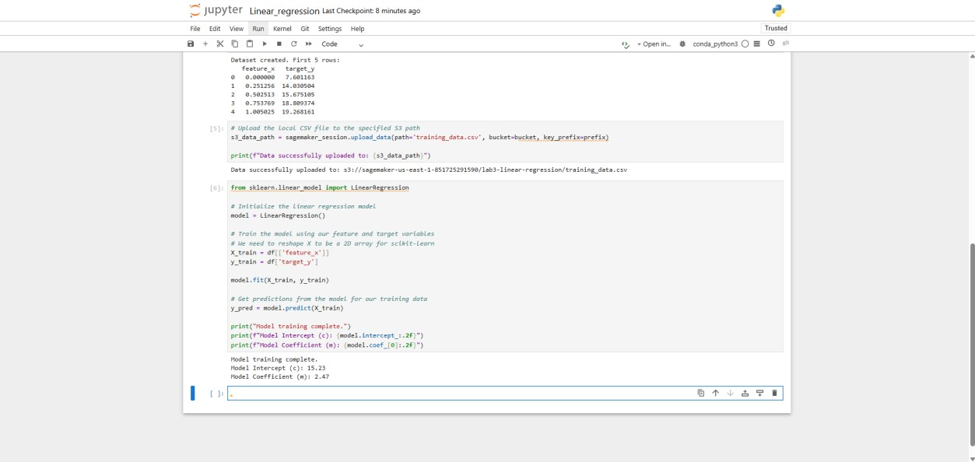
Step 5: Evaluate the Model Performance
Now we calculate the Mean Squared Error (MSE) to see how well our model performed.
Run this code to calculate and print the MSE.
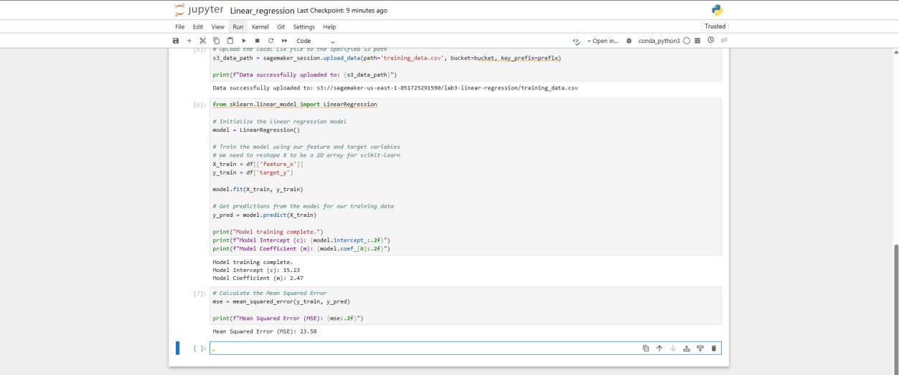

Step 6: Visualize the Results
The best way to understand the model's performance is to plot the results. We will create a scatter plot of the original data and overlay our model's regression line.
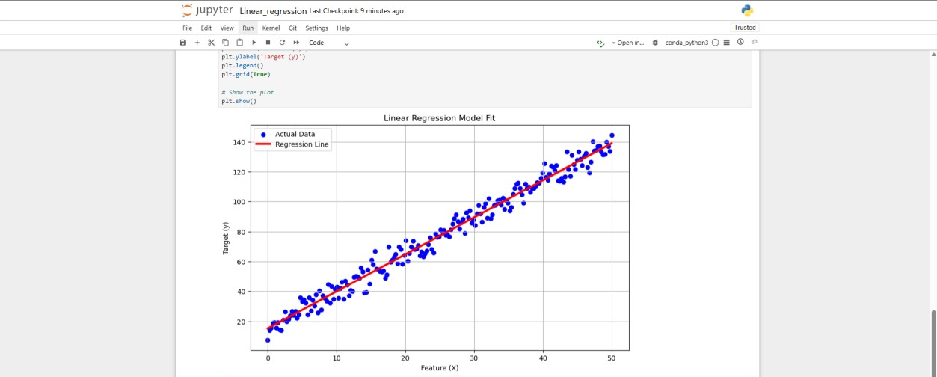
Execute the final cell to generate the plot.

Conclusion:
In this lab, we successfully utilized an Amazon SageMaker notebook to perform an end-toend machine learning task. We began by generating a dataset and storing it in Amazon S3, a best practice for cloud-based ML workflows. We then trained a simple linear regression model directly within the notebook, evaluated its performance by calculating the Mean Squared Error, and created a clear visualization showing the relationship between the actual data and the model's predictions. This exercise demonstrates the power and convenience of using SageMaker as an integrated environment for data analysis and model building.

